Introduction to SAS
Assignment 1
Getting Ready:
- Download and unzip the file: labdata.zip to your desktop. Put these files into a folder on your desktop called LABDATA.
- Set your default folder for SAS, so that it points to the LABDATA folder (refer to "Getting Started with SAS.pdf" for instructions).
- Open the SAS program intro.sas, using the steps shown below:

- Go to the SAS command file editor window, and select File > Open Program:
- Select the file intro.sas and double-click, or click on "Open"
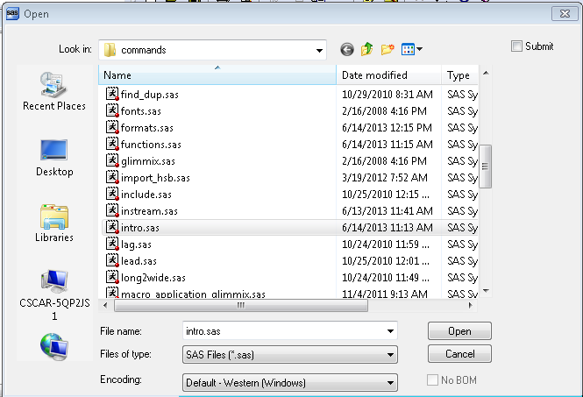

- Submit the entire file. You can do this by highlighting the entire file, and clicking on the running person icon. You can also submit the entire file by not highlighting anything in it, and clicking the submit icon.
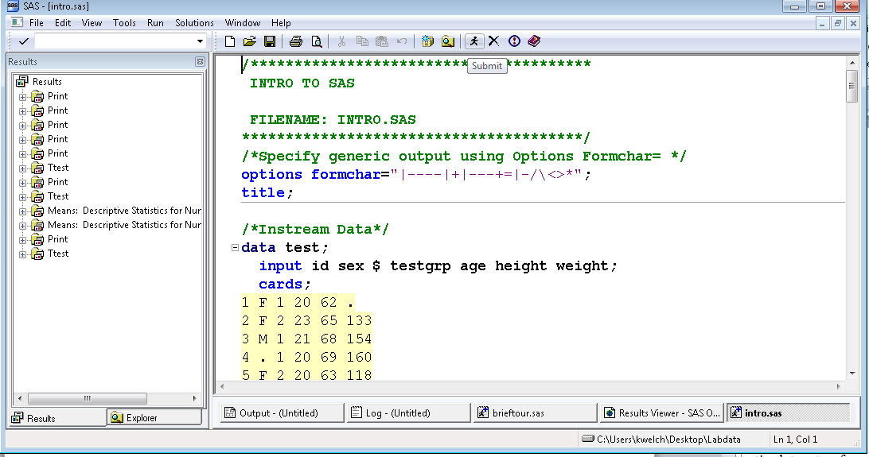
- Browse the PULSE data set that you created in the Work Library. How many observations and how many variables are in this data set? After browsing, close this file, without closing SAS.

- To do this, go to the Explorer Window, and double-click on the Libraries icon

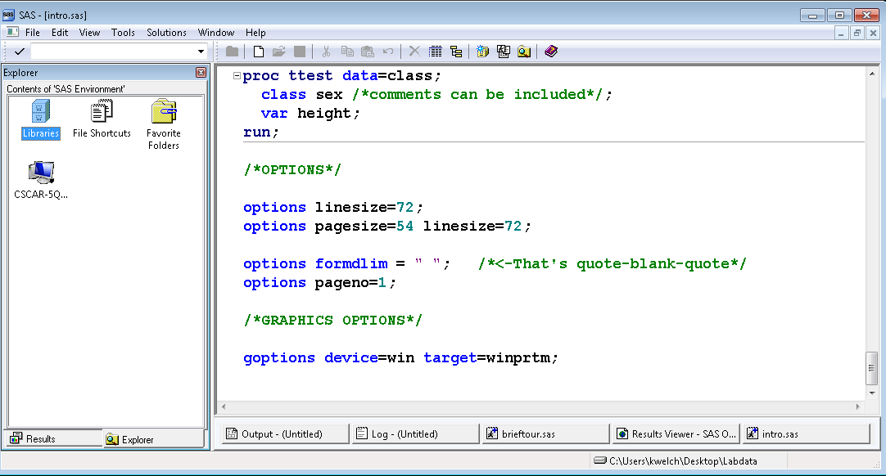

- In the Active Libraries Window, double-click on the Work icon.
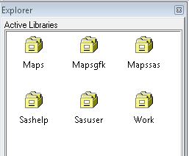

Double Click on the Pulse data set, to open it for browsing.
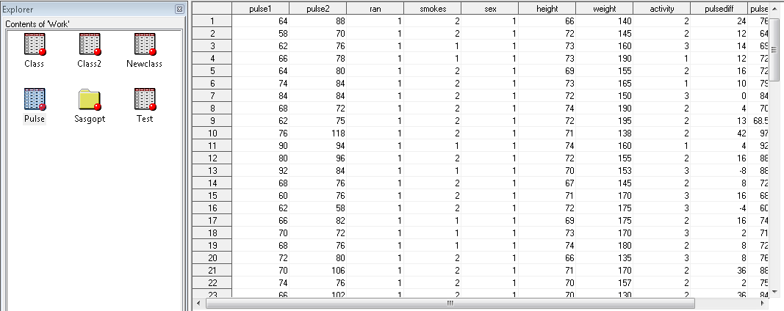

- Copy and paste a portion of the output to a Word Document. To do this, go to the Results Viewer and select the portion of the output that you wish to put into your document. Do not print the entire output.
- Copy and paste one graph generated by this command file into the same Word Document.
- Save your Word Document, and print it.
- Make sure your name is on the paper.

